Spin And Marty And The Film Ranches near William S. Hart's Ranch

*by the webmaster of the Spin and Marty site, cinchset.com*

Today location filming is largely done with Computers. In the early years of western film production was it was the location, the “movie ranch” producers relied upon for their action scenes. In those early years film producers relied upon location scouts to find the right spot to shoot various scenes. Many of those several choice locations were discovered in Placerita Canyon, Chatsworth and the Simi Valley.

As the author of a small out of the way web site devoted to documenting the history and filming locations of the 1955 Walt Disney, Mickey Mouse Club series, *ADVENTURES OF SPIN AND MARTY*, someone felt I knew a bit about the subject and asked me to write a short article describing the ranches used in the filming. So let me start by saying it’s impossible to write a “short” article about those ranches. Impossible simply because their histories are so long. I freely admit that I research, write, illustrate, edit, code and generally take credit for the cinchset.com web site; which, at 101 pages, is not in any way connected with the Disney Company.

Please forgive the briefness of this article and accept it as it is, about as brief and still detailed as I can manage.

The first season of Disney’s Spin and Marty serial required filming at four separate locations. The Golden Oak Ranch served as the main setting for the Triple-R ranch with the bunkhouse, chow hall, managers’ office and of course the barns. Now over 800 acres in size, it was only 300 acres in 1955 when Walt filmed his series there and before purchasing it from Lloyd Earl in 1959, two years after filming the last Spin And Marty episode in 1957. Those who remember the Triple-R campfire scenes with the boys singing Yippi-A, Yippi-I, Yippi-O will be happy to know that portion of the Golden Oak Ranch remains the same today as it was then. The weeds and trees have grown some but the area still looks the same today as does that portion of Placerita Creek where Joe Simpson (Sammy Ogg) captures the frog to put in Marty’s (David Stollery) bunk leading to the boxing match in episode 5.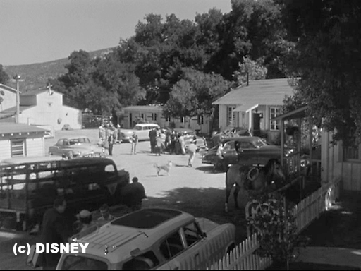

Of the many buildings seen above, only the garage (blacksmith’s shop in the series) and the feed barn, now called the Ragwing barn, remain.

The Golden Oak was a working ranch during the years that Walt rented it. Cattle and horses of course but also grazing a fair number of sheep. Sheep which are clearly seen in a 1953 Roy Rogers episode and further attested to by the presents of a large sheep shed—later to be converted into the now well-known stables seen in many Disney TV programs and movies. Indeed the attentive viewer can see ranch hands tending the stock in the background of one episode of Spin and Marty as well as cars passing along Delden Road, then a public road cutting through the ranch.

It’s a fact of life that all directors have to contend with unexpected problems during filming. One such problem was the construction of Placerita Canyon Road which was being cut through the hills literally along the ranches southern boundary. Indeed that new road cut close to if not through both the Golden Oak and Walker ranches. Just what every director needs; the sound of heavy earth moving equipment echoing back and forth in the canyons as dust clouds drift across the set. Sharp eyed viewers of the series can find two frames in episode 22 which, for a split second, show Placerita Canyon Road in the early stages of construction.

The Golden Oak Ranch had been a film location long before Walt Disney chose to use it for his Mickey Mouse Club series. Both Roy Rogers and Gene Autry had used it in the early 50’s, in fact were still using it, to film scenes for their weekly television programs just prior to and during the filming of the Spin and Marty series. With its long dirt roads it was ideal for filming chase scenes or those depicting lonely wide open western spaces. It’s even harder to imagine such larger than life actors as William S. Hart not utilizing them in some of his westerns.

Technically speaking in 1955 Gene Autry’s Flying ‘A’ Productions was filming *The Adventures Of Champion* at the Andy Jauregui ranch just west of the Golden Oak using the GOR’s wide open fields as a background. But several times they found the ranch house and yard convenient, before Walt set about modifying them for the Triple-R set. Andy’s place was also a frequent location site for many television programs including some of The Lone Ranger programs.

Unfortunately the Golden Oak Ranch is closed to the public and, alas, no tours are available. Hey, it’s a working movie ranch now and almost constantly in use by one or more production companies.

Of more interest to neighbor Frank Walker was the Golden Oaks’ chicken coop. Frank’s diary details purchasing eggs from the then Lloyd Earl ranch as well as entries about his sons working at there on several occasions, repairing fences and such.

A recent attempt at cataloging all the films shot at Franks ranch produced a list of 150 titles starting with *Call Of The Desert* in 1930. There are likely many more titles still too be discovered and added to the list. Being adjacent to the Golden Oak Ranch it provided producers with nearly 600 acres of diverse settings. Everything from long wide chase roads to rugged mountainous terrain and wooded areas.

Frank sold his ranch to the State of California in 1959 later (the same years Walt Disney bought the Golden Oak Ranch) to become the Placerita Canyon State Park and Nature Center. Several Spin and Marty episodes depicting typical campout events were filmed there along with the first episode opening sequences and a Snipe Hunt. Who in the 50’s hadn’t gone on a snipe hunt and recalled the event after seeing the episode?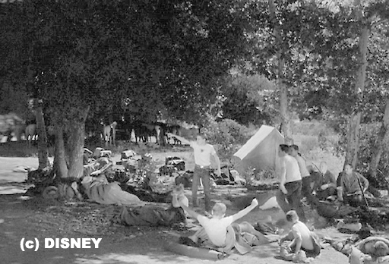

During a visit to the nature Center in 2014 I was happy to find the trees seen in the TV episodes and films are still there. Two small trees near the cabin have died but the rest stand tall. Quite a bit taller now of course yet there’s no denying that these are the same trees. On my web site I have tinkered together a panoramic image of the Walker winter cabin used as a set in the 1939 production of *Oklahoma Terror* staring Jack Randall. In the Spin and Marty, Live Ghost episode the cabin was dressed as a dilapidated old shack but today it has been restored, resembling as closely as possible, the Walker winter residence when the family lived there. It’s open to the public several days a week for those who want to walk around inside a piece of Americana and film history.

During my visit I watched as many people walked about the area never suspecting they were walking in the footsteps of the

Triple-R boys or any number of larger than life movie stars such as William S. Hart, John Wayne and a host of others.

One little known but often used set at the Walker Ranch was a mine entrance. This prop was somewhat portable as it appears to moves from one place to another in several movies. It was just a prop after all, however, the Walker Ranch did have a real gold mine along with an oil well. I’m told the real mine is still there today...minus the gold and never looked like the prop. Now the mine entrance in Spin and Marty may be long gone but those familiar with the series, and who take the time, can still see where it was located behind and just west of the cabin.

Guided tours are offered at the Nature Center as well as maps and information for self-guided tours along well marked trails. One such will take you past the Oak of the Golden Dream where Francisco Lopez is said to have discovered gold on March 9, 1842. Camp sites are available at the state park for those who wish to spend more than a few hours there.

The Iverson Movie Ranch in Chatsworth served as the setting for the more serious episodes of Disney’s serial. It’s stark, lonely appearance added drama to the episode triggering an emotional response even in young viewers exactly as director William Beaudine knew it would. It’s difficult to think that such landscape would require any set dressing but they did in fact place two small bushes beside the dirt road for one sequence. They lend nothing to the scenery but work well on a subliminal level representing a gateway through which Marty (David Stollery) must choose to pass through. A gateway leading Marty to a new outlook on life and friendships. Heavy stuff for the average 10 or 11 year old in 1955 but we all took it in stride and never noticed the obviously potted plants.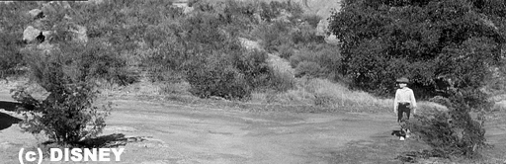

The Iverson Movie Ranch is a marvel to wander around in. It’s a park now—those portions not having been transformed into condos at least. I’m happy to say the locations used in filming Spin and Marty are within the park. Movie buffs will quickly recognize many other locations used in some of the more than 3,000 ‘A’ and ‘B’ films filmed there. The Iverson’s first use as a movie location seems to have occurred in 1912 with the shooting of *Man's Genesis* staring W. Chrystie Miller. Not long after William S. Hart would be there staring in *The Tiger Man* (1918).

It’s an amazing experience to be able to locate the various set areas and discover, or rediscover, many of the sets used in still popular movies. One of the more recognizable rock formations is The Long Ranger Rock which is easily seen from Redmesa Road and accessible to hikers as is the old stagecoach road used in so many westerns.

The place is surprisingly compact and easily hiked. I do recommend you bring along both a camera and a canteen as it gets mighty hot there in the summer months. OH, and unlike the Placerita Canyon Nature Center, there are no facilities provided if you take my meaning. Just be aware that rattlesnakes frequent the area should you decide to venture into the bushes or go exploring the rocks. Watch where you’re stepping or about to put your hands.

The rodeo competition, the final four episodes of the first season series, was filmed on location at the then Sunshine Rancho in Canoga Park. Located just four or five miles south of the Iverson Movie Ranch along a then narrow two lane Topanga Canyon Road it was easily accessible to film crews. At the time it was a popular arena where up and coming cowpokes practiced their rodeo skills on weekends as well as being a sometimes movie location. Gene Autry’s *Adventures Of Champion* television series appears to have used it, if not at the same time, then judging from the shadows, close to the time Disney was filming there. Now it is an apartment complex as is a large portion of the old Iverson movie ranch and most other movie company back lots of the day.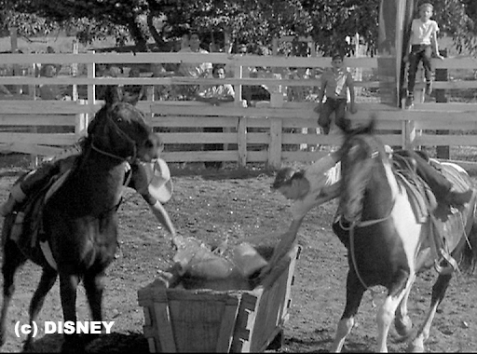

And yet there was a fifth ranch of somewhat greater importance to the series. The Broadview Ranch in Lexington, Virginia, for it was there that Lawrence Edward Watkin found the material he used to write his novel, Marty Markham (1942), on which Walt Disney based his series. Watkin’s book describes actual events, somewhat embellished, which occurred at the Broadview ranch over a period of several summers before World War Two put an end to the boys summer fun. Events including one in which a boy named Martin arrived at the ranch...with his butler.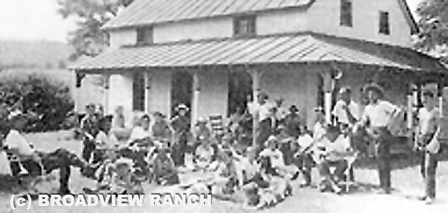

One object of my 2014 research trip to the Golden Oak Ranch was to attempt to locate the exact, if not precise, location of Trem Carr’s original Monogram studios. Using numerous images captured from early Monogram films we attempted to match the backgrounds in the pictures with those visible today. Line up several of these and we would be standing on the exact spot the camera was located during the filming. Sounds easy but in practice it’s rather difficult considering that a perfect match would have required us to stand in the middle of the Antelope Valley Freeway (Hwy 14).

The widely popular age of American westerns got its start in New Jersey with *The Great Train Robbery* (1903) yet it quickly found a new home in Hollywood. Today it seems to have moved further away, to Australia and Spain where open space and the “wild west” scenery is still available. And yet the old westerns where good overcomes evil in the end are still popular. Among them the clean cut hero’s such as William S. Hart, Tin McCoy, Ken Manard, John Wayne, Harry Carey and so many others. Shoot’em Ups we called them but in reality they were, in their own way, morality tales. Stories which encouraged doing the right thing for the right reasons. Ideals which we kids of the day, and adults, appreciated.